

**Computer & Electronic Engineering**

**Final Year Project "Music Host Interface"**

**Sprint 4: Week 1 Log**

**Thomas Flynn**

**Project Supervisor: Brian O'Shea**

**17/01/16**

# 1 Log Entries

## 1.1.0 Entry 1: 17/03/16

My first week back has primarily been spent procrastinating. So I decided the best way to do that would be to spend my time procrastinating on a podcast that deals with the subject. Making the transition from doing very little over an extended period of time to being productive once again won't be an overnight change.

Fortunately I'm spending my time avoiding doing work on my project by researching the reasons why I won't do work on my project. I'm hoping next week will be a more productive week. The link to the **procrastinate podcast** is below.

At the very least I was able to organise my board into a somewhat coherent and logical order of tasks to be completed. I know what needs to be done, which is a start I guess.

# 2 Research done:

Procrastination.

# 3 Tasks completed:

Organised project board.

# 4 Board at the start/end of the week:

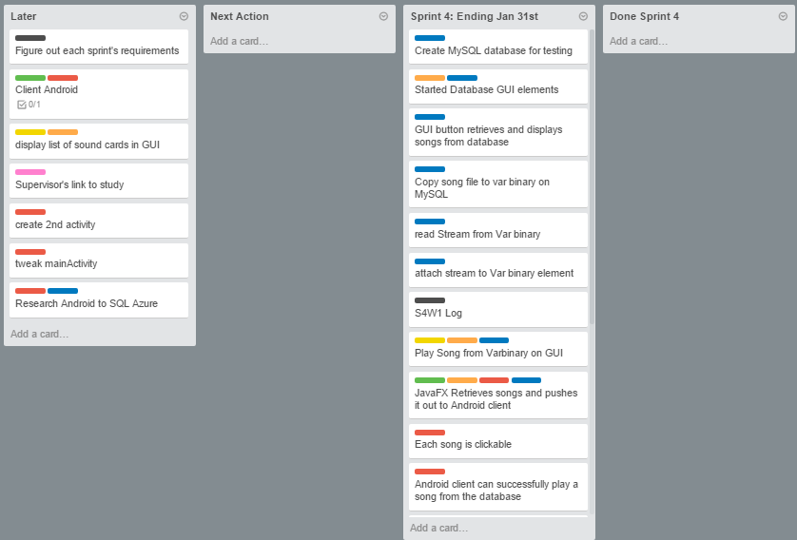

# 5 Toggl Time Logs

## 5.1 Weekly time Log bar chart:

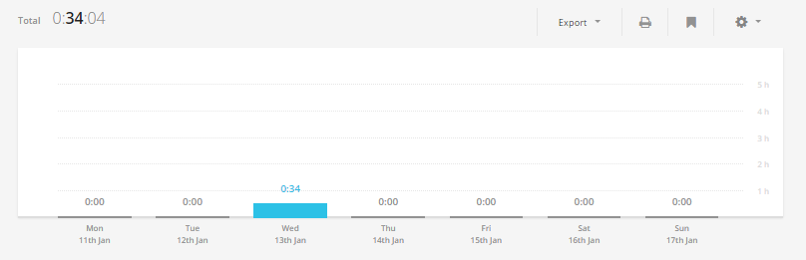

## 5.2 Weekly Time Log:

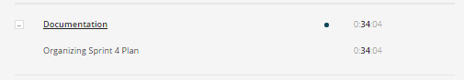

## 5.3 Weekly log Pie Charts:

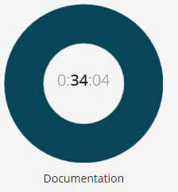

# 6 Link References:

<http://iprocrastinate.libsyn.com/webpage/category/podcasts>